How to add CSV to AWS S3 storage:

Step 1: Go to <https://aws.amazon.com/>, and click sign in to the console to sign in as root user.

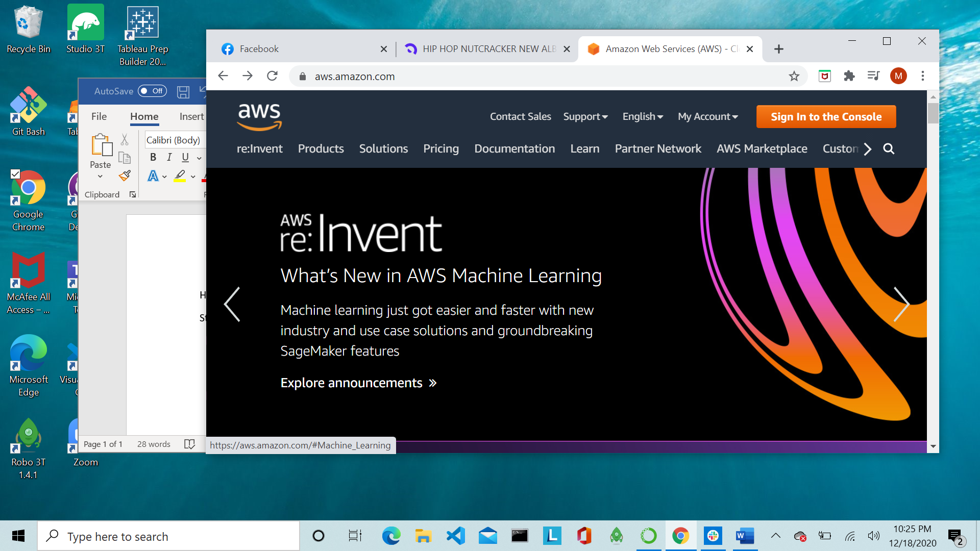



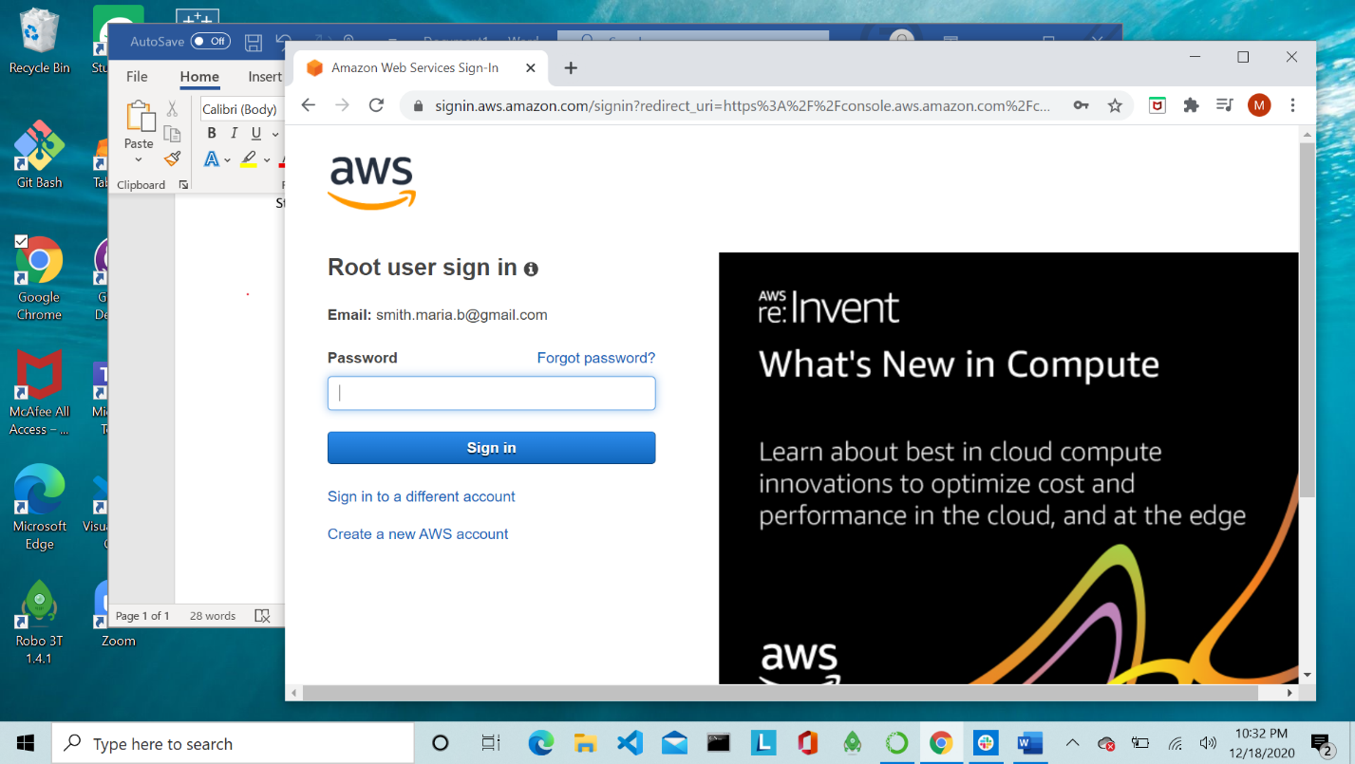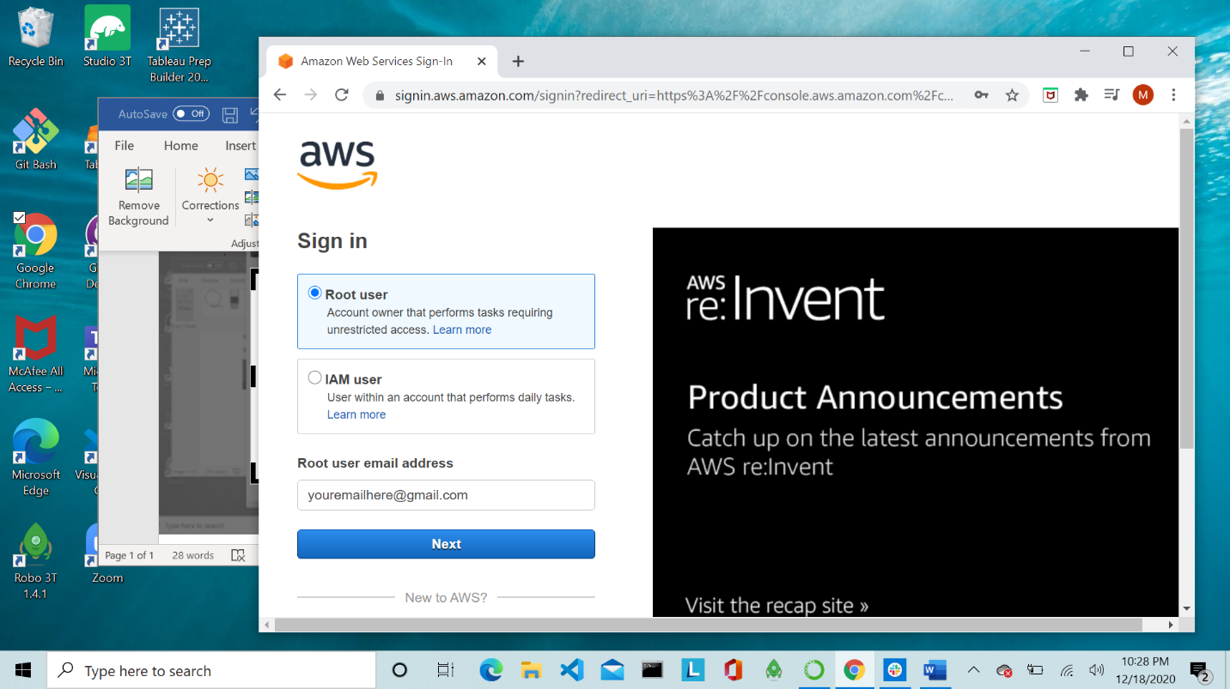



Step 2: Once you are logged in, click the dropdown that says services, and select S3.

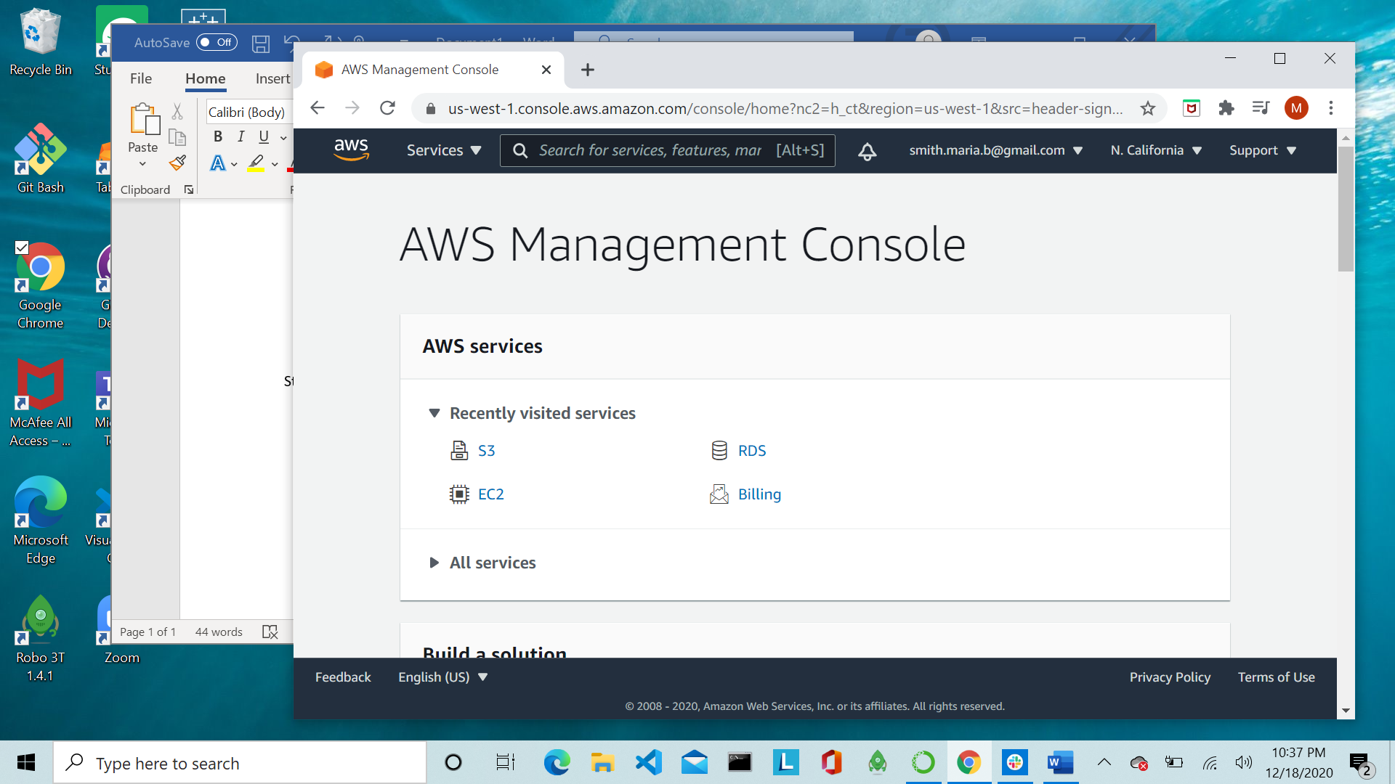



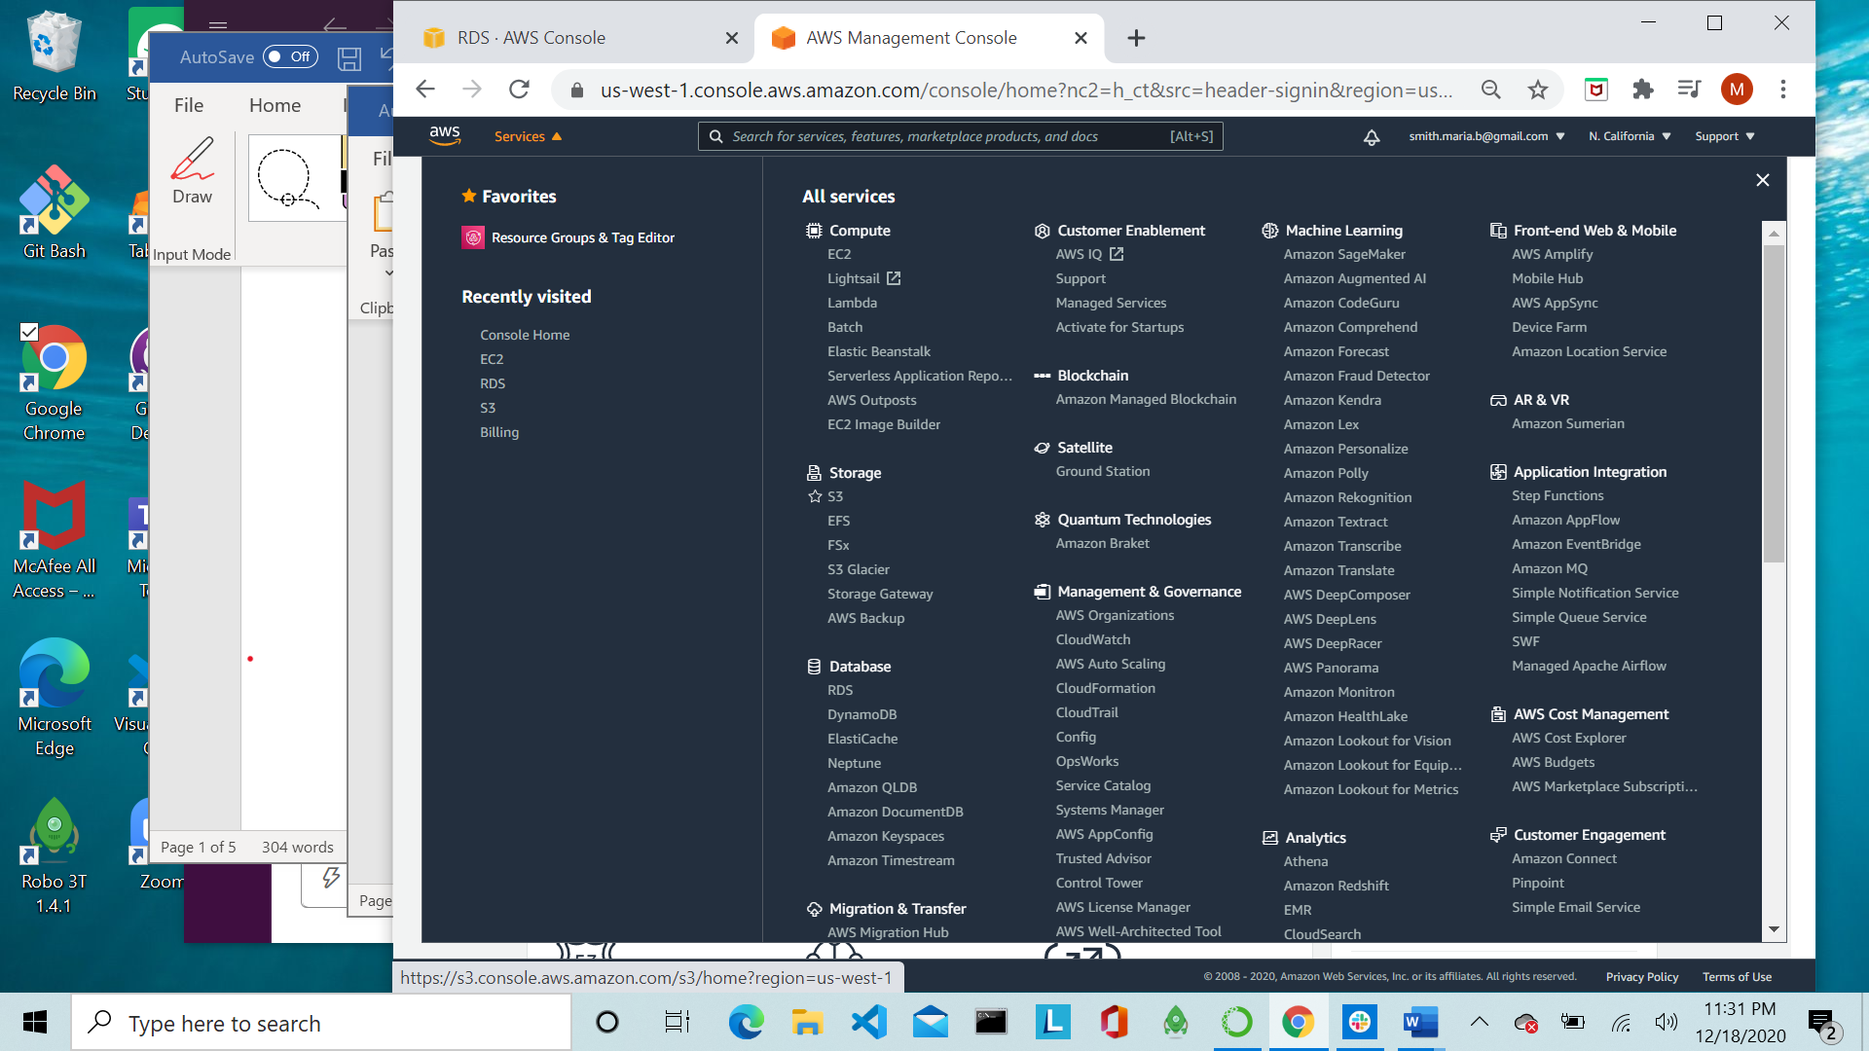

Step 3: Create a bucket

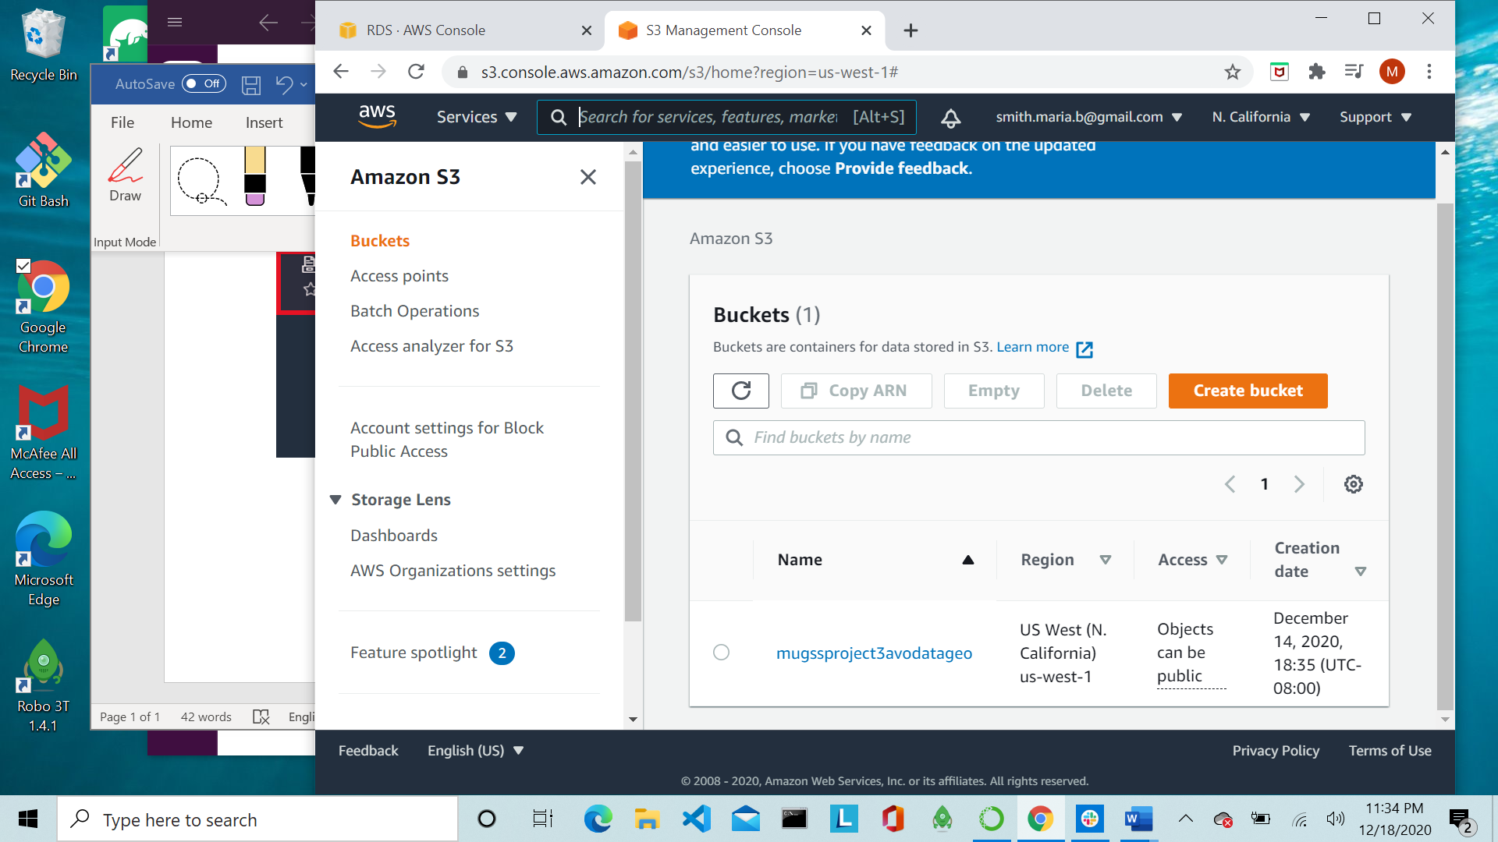

Step 4: Name and configure bucket. \*\*\*Make sure bucket region matches DB region\*\*\*

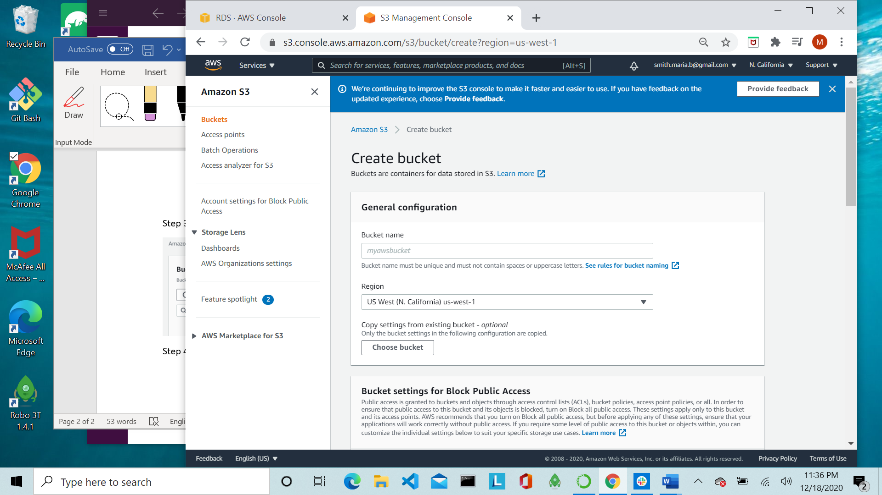

Step 5: Make bucket public.

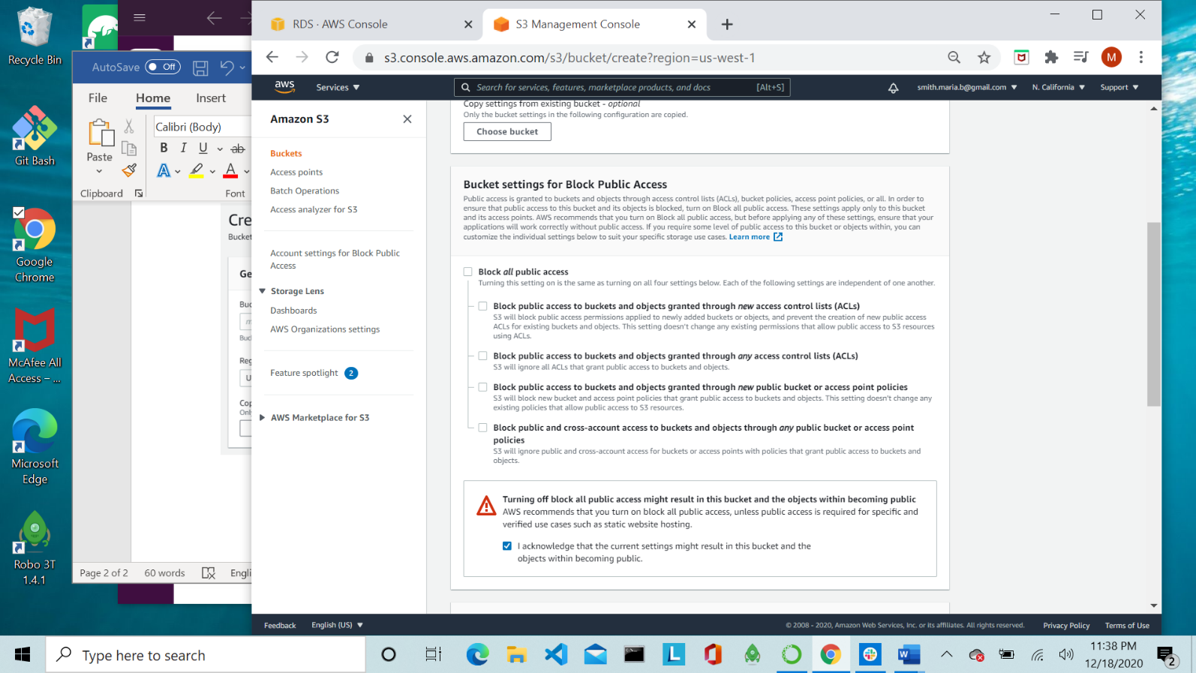

Uncheck box that blocks public access.

Check the acknowledgement box

Step 6: Select the Create bucket button at the bottom of the page

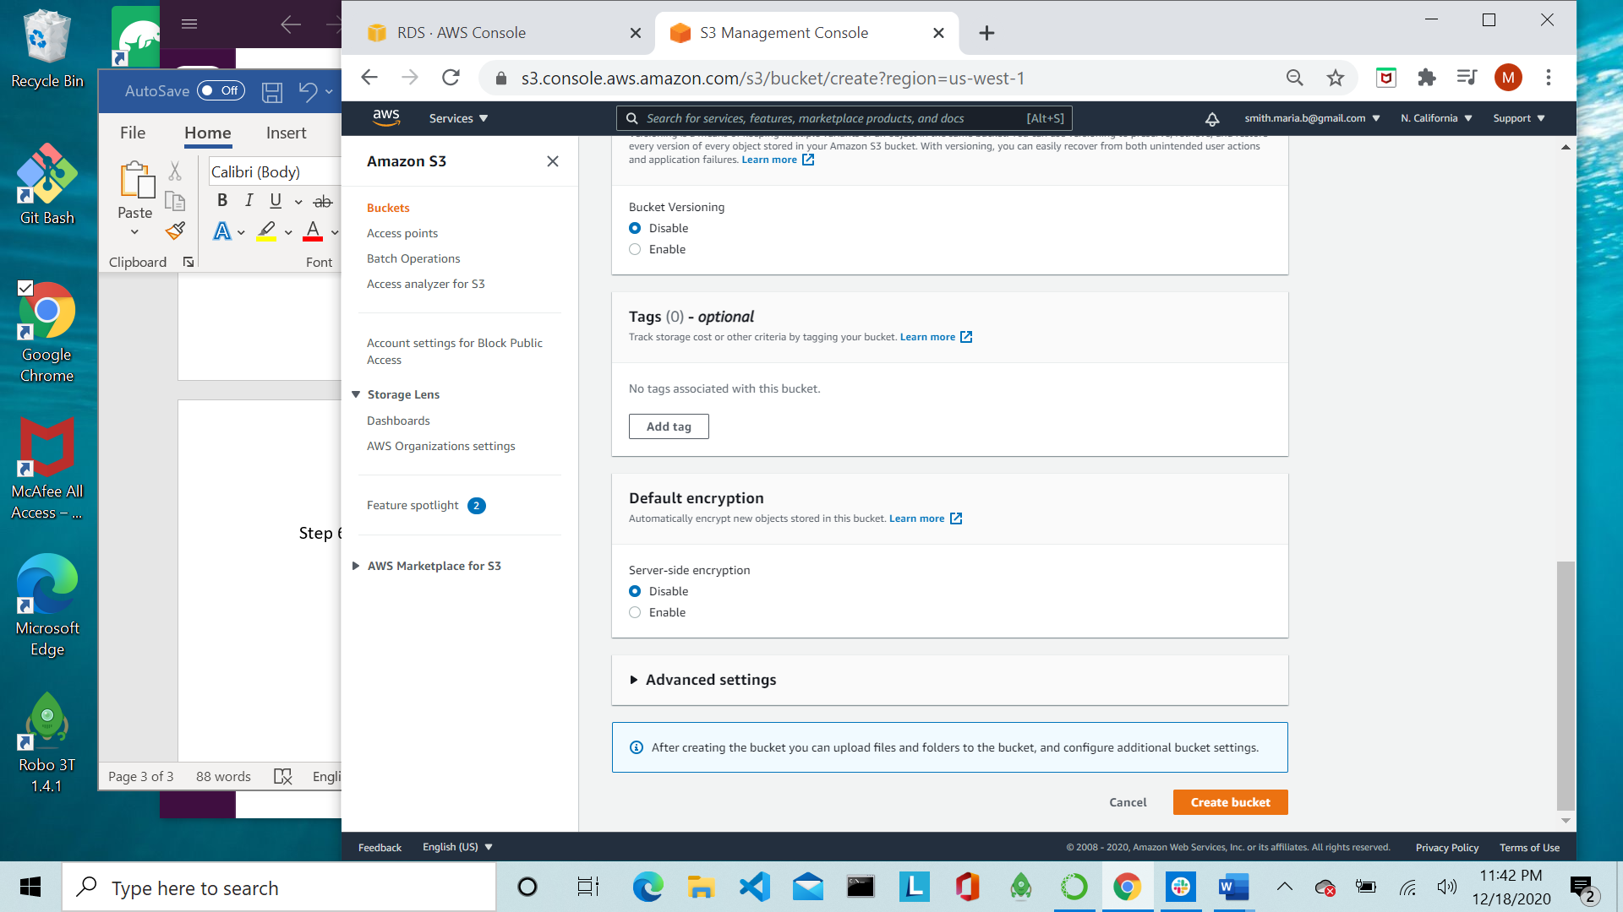

Step 7: Select the bucket hyperlink to be able to load data

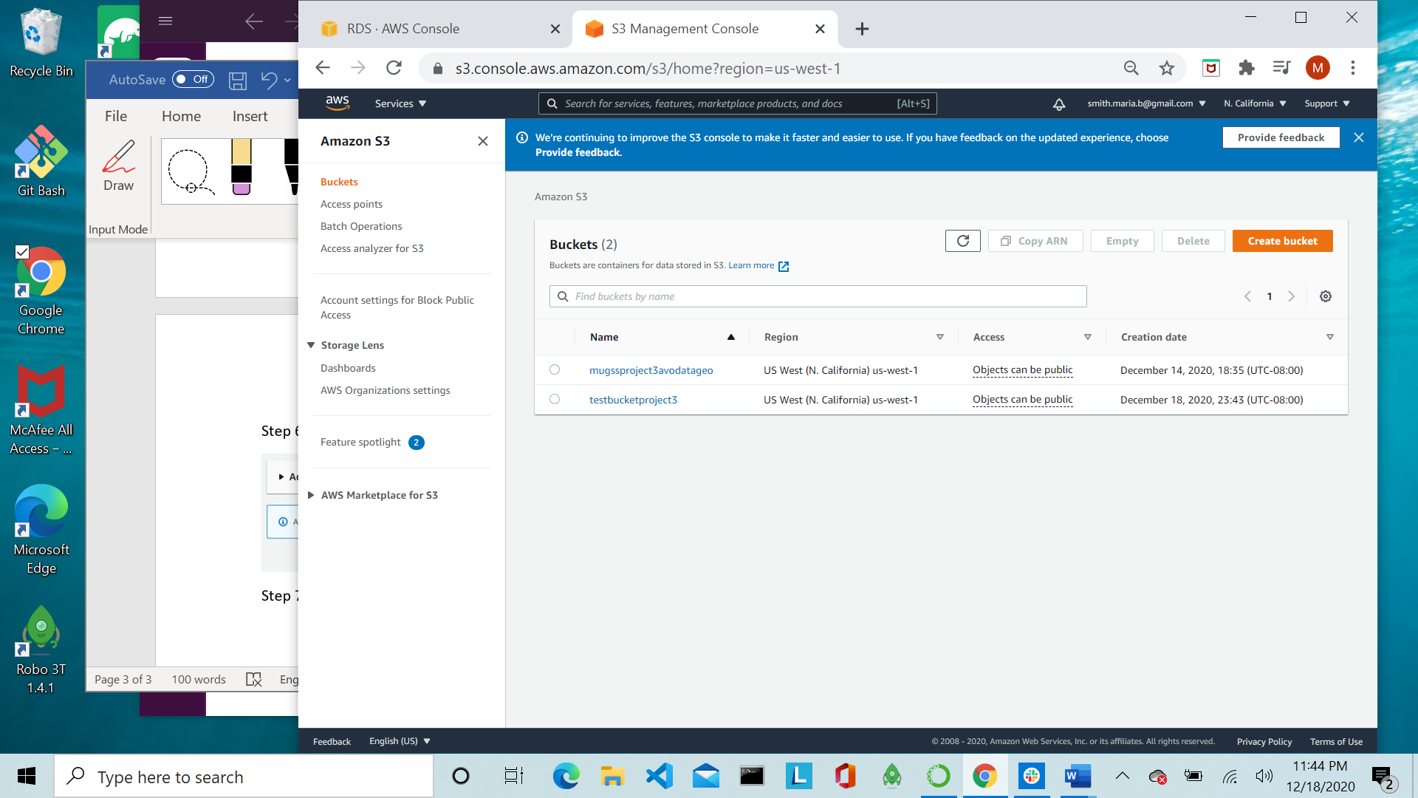



Step 8: Click the upload button

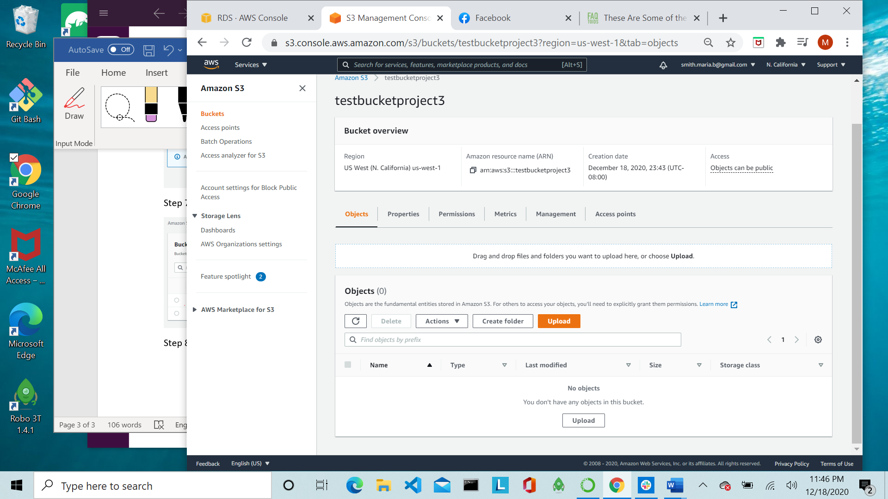



Step 9: Add .csv file from your computer

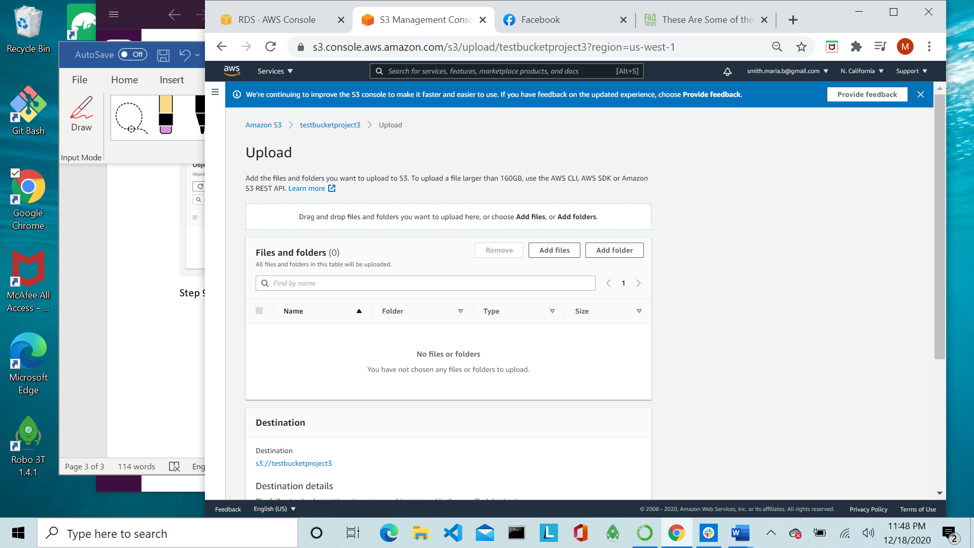

Step 10: Upload file by selecting the upload file button at the bottom of the page

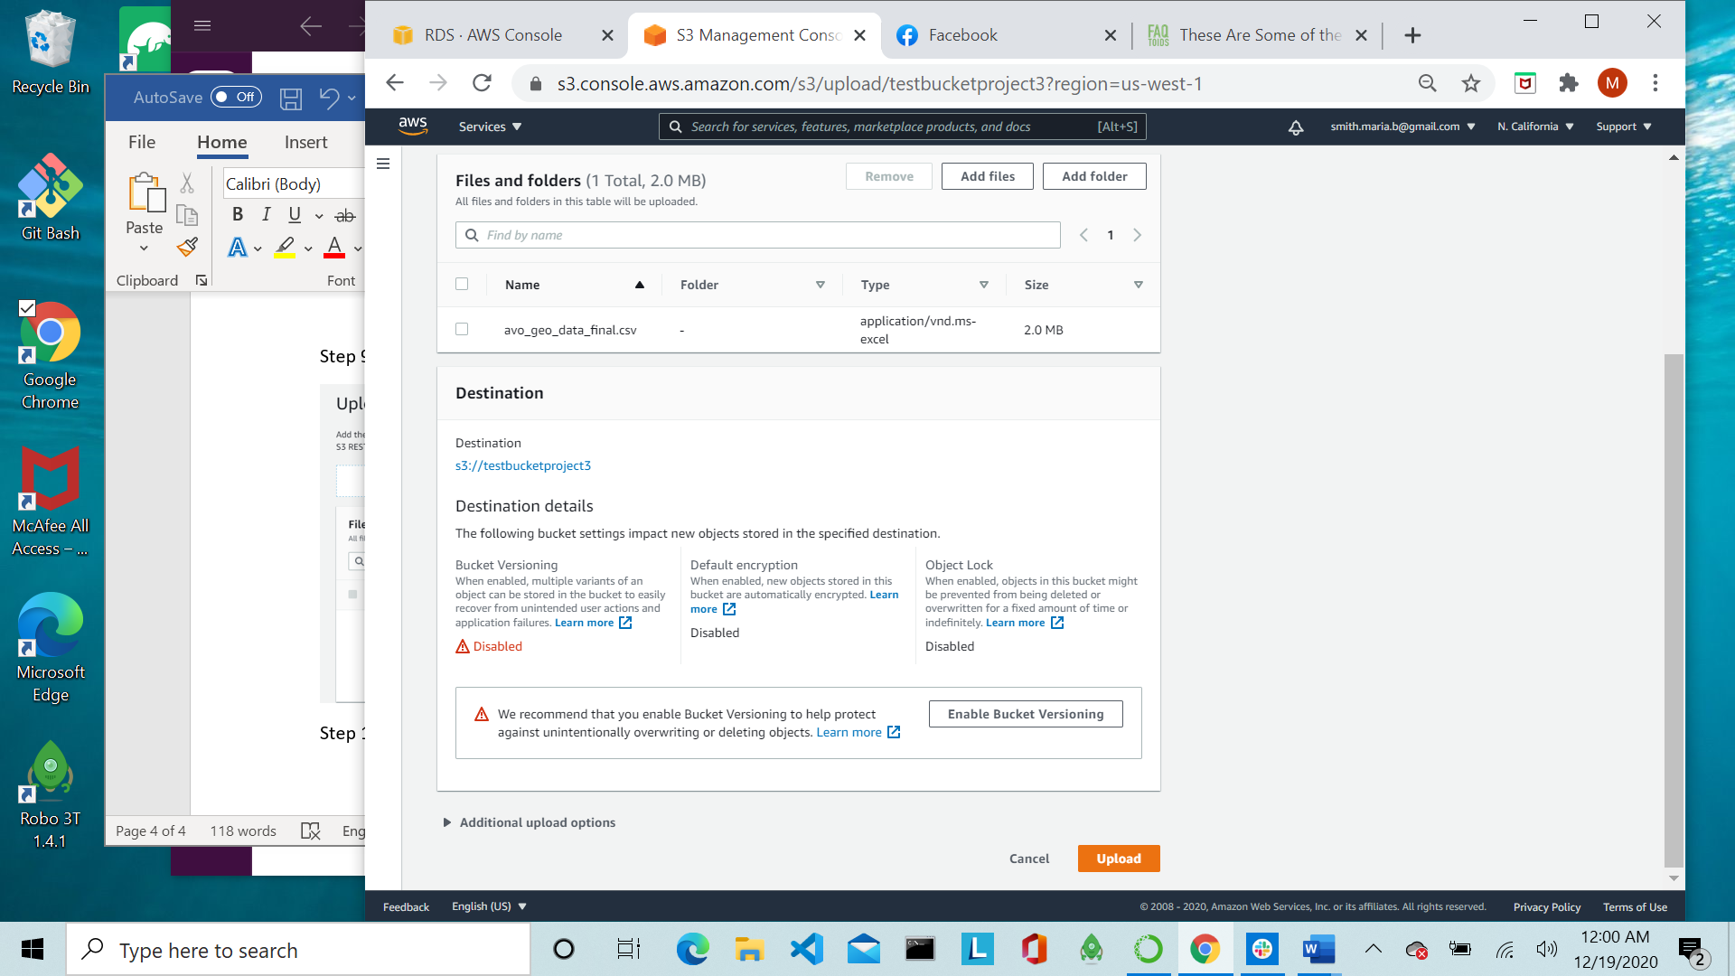

Step 11: Make file public by selecting the file, then clicking on the Actions dropdown and selecting “Make public”. Once you are taken to the next screen select the “Make public button”

